# Online bookstore

This is a more traditional database heavy application.

# Database design

This app can revolve around these designs, but can also be significantly simpler.

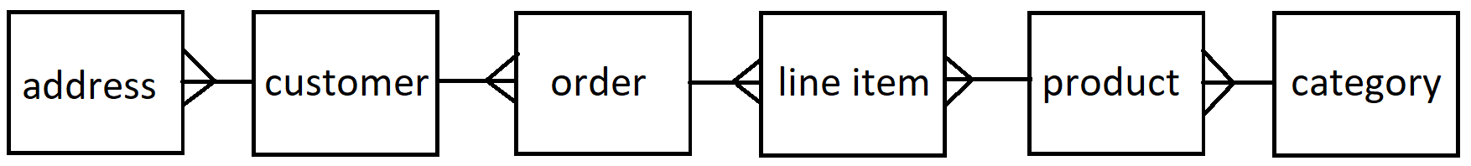

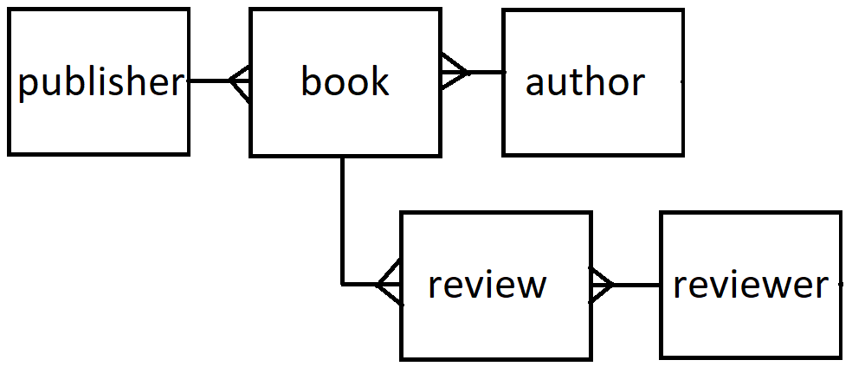

# Customer

Customer and reviewer here can be the same table and they represent a user in this system.

# Book

A book in abstract more generally a ‘product’ has many copies or ‘line items’ which you are going to sell. ‘Products’ or books are what a user sees when they navigate through the online bookshop but it is copies of ‘line items’ that they actually buy.

# Order

An order is what associates the customer with books for which line items are to be delivered.

# Additional things to think about

Error handling

Testing

Documentation (User guide / walkthrough && readme)